**Overview:** Demonstrate the performance of a voltage divider circuit and a Wheatstone bridge circuit.

**Student Learning Outcomes:**

1. Measure DC voltage, resistance, and current with a true RMS multimeter
2. Interpret resistor codes to determine nominal resistance value
3. Compare nominal resistor values with measured resistance
4. Construct simple analog circuits on a breadboard with DC power supply

**Pre-Lab:** Read the files provided on iLearn to ensure you are ready to take on the Lab Challenge 2. These files include user manuals for the multimeter and power supply benchtop instruments, as well as files that detail resistance and capacitor codes. It is strongly suggested that you review equations from your ECE Circuits course to ensure you can predict values for current, voltage, and resistance in a circuit.

Lab Guidance (You determine the experiment design and process):

Notes: (1) In this and all subsequent measurements, be sure to record the data to the highest precision available from the instrument. (2) Use the measured values for resistance in all subsequent calculations instead of the nominal values.

Activity 1) Series and Parallel Resistor Circuit, acting as a voltage divider

Study the diagram and construct the series-parallel resistive circuit shown which acts as a voltage divider. Predict the circuit behavior using the required equations in parametric form. Verify the expected values using the lab instruments to measure the physical values in the circuit.

**1a) Resistance Measurement**

Locate resistors R1, R2, and R3 for activity 1 using the resistor color codes, and verify the values by measuring the resistance of each resistor with the meter before placing it in the circuit. After constructing the circuit, measure resistance across the parallel set of two resistors (), then across the set of all three resistors (). Measure resistance with the power source turned off ().

Table 1.1 – Voltage Divider Resistances

|  |  |  |  |
| --- | --- | --- | --- |
|  | Expected Resistance [Ω] | Measured Resistance [Ω] | Percent Diff. [%] |
|  |  |  |  |
|  |  |  |  |
|  |  |  |  |
|  |  |  |  |
|  |  |  |  |

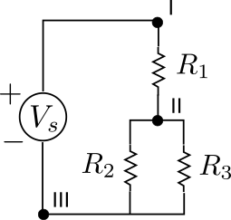

Figure 1.1 – Voltage Divider Circuit

*Observe and Discuss:* Compare your analysis and expected value(s) with what you measure.

**1b) Voltage and Current Measurement**

Using the DC power supply, connect an input voltage of volts from node III to node I as shown in Figure 1.1. Verify the source voltage by measuring between node III and node I (. Measure the top voltage between node II and node I (and the bottom voltage between node III and node II (). The top and bottom voltages of the divider circuit should sum to equal the source voltage. Compare the measured values to the expected values from the voltage divider equation.

|  |  |  |  |
| --- | --- | --- | --- |
|  | Calculated Voltage [V] | Measured Voltage [V] | Percent Diff. (%) |
|  | Vs |  |  |
|  |  |  |  |
|  |  |  |  |

Table 1.2 – Voltage Divider Voltages

Measure the current in the circuit at node III and compare this to the expected calculated value. The multimeter must be in SERIES with the circuit for current measurement.

Table 1.3 – Voltage Divider Current

|  |  |  |  |
| --- | --- | --- | --- |
|  | Calculated Current [A] | Measured Current [A] | Percent Diff. (%) |
|  |  |  |  |

*Observe and Discuss:* Compare your analysis and expected value(s) with what you measure.

**Activity 2) Wheatstone Bridge Circuit**

Analyze and then construct the circuit shown with the indicated nominal R1, R2, R3, R4 values assigned for activity 2. Calculate the expected bridge voltage and measure the actual bridge voltage between nodes I and II for each circuit, Q1, Q2, and Q3 as shown in Table 2.1 below.

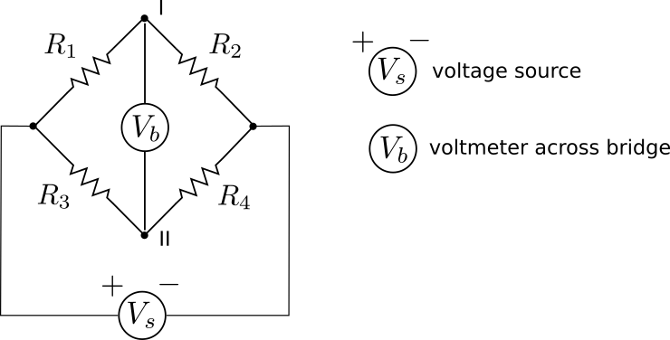

**Figure 2.1 – Wheatstone Bridge Circuit**

**Table 2.1 – Wheatstone Bridge Data**

|  |  |  |  |  |  |  |
| --- | --- | --- | --- | --- | --- | --- |
| **Circuit #** | **R1 [kΩ]** | **R2 [kΩ]** | **R3 [kΩ]** | **R4 [kΩ]** | **Calculated [V]** | **Measured [V]** |
| Q1 |  |  |  |  |  |  |
| Q2 |  |  |  |  |  |  |

*Observe and Discuss:* Compare your analysis and expected value(s) with what you measure

**Data Analysis:**

* In the spreadsheet, be sure to include raw data you measured for each activity and compute percent differences between nominal and/or calculated values and measured values

**Deliverables:**Refer to Challenge 1 and/or the iLearn site to see general format